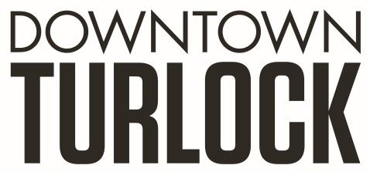
115 S Golden State Blvd, Turlock, CA 95380
Phone: (209) 634-6459
admin@turlockdowntown.com
_________________________________________________________________________________________

TDPOA BOARD SPECIAL MEETING AGENDA
Friday, March 29, 2019
9:00 am
Chamber of Commerce Board Room
115 South Golden State Blvd. Turlock, CA 95380

Board Members: Michael Camara Marin Krieger Charlene Costa Dan Tallman
Danny Mann Candace Gonsalves Nathan Dabulewicz Randy Woods Jeff Chapman

Executive Director: Molly Amant

Call to Order:

- Public Comment: While participation of all interested parties is welcomed, State Law prohibits the Board from taking action on any item not listed on the Agenda.

- Discussion/Action Item:

  - Block to Block Presentation- Downtown Chico Ambassadors

- Closed Session: None

- Board Member Comment(s)
Board members may provide a brief report on notable topics of interest. The Brown Act does not allow discussion or action by the Board.

- Announcements and Discussion Items for next Meeting:

- Adjournment

