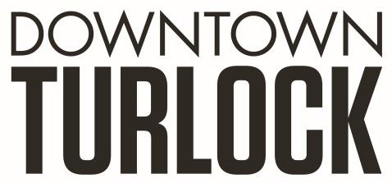
115 S Golden State Blvd, Turlock, CA 95380
Phone: (209) 634-6459
admin@turlockdowntown.com
director@turlockdowntown.com

_____________________________________________________________________________________
TDPOA BOARD MEETING AGENDA
Wednesday, October 26, 2022
3:30 PM – 5:00 PM
Chamber of Commerce Board Room
115 South Golden State Blvd. Turlock, CA 95380

Zoom Link: https://us02web.zoom.us/j/84835555638

Board Members: Dan Tallman Lori Smith Amy Wilson Danny Mann Devin Hill Alta Fernandes Randy Woods Jeff Chapman

Executive Director: Molly Amant/ Travis Regalo

Call to Order:

- Public Comment: While participation of all interested parties is welcomed, State Law prohibits the Board from taking action on any item not listed on the Agenda.

- Scheduled Matters:

  - Review and Approval of Minutes from September 21, 2022
  - Approval of Financial Report
  - Staff Updates- MA/TR
  - Merchant Group Update-LS

- Discussion/Action Item:

  - Pots/ Fly Issue
  - Benches
  - PBID Rewrite
  - Festival of Lights
  - Christmas Parade
  - Downtown Light Project
  - Update Signers of Checks on F&M Account
  - Fee Increase Stuart Property Services

- Board Member Comment(s)
Board members may provide a brief report on notable topics of interest. The Brown Act does not allow discussion or action by the Board.

- Announcements and Discussion Items for next Meeting:

- Closed Session

  - Employee review
  - Personnel Employment Details

- Adjournment

