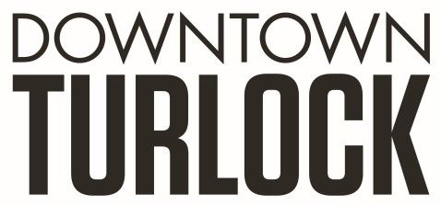
115 S Golden State Blvd, Turlock, CA 95380
Phone: (209) 634-6459
admin@turlockdowntown.com
_________________________________________________________________________________________

TDPOA BOARD REGULAR MEETING AGENDA
Wednesday, June 19, 2019
3:30 PM – 5:00 PM
Chamber of Commerce Board Room
115 South Golden State Blvd. Turlock, CA 95380

Board Members: Michael Camara Marin Krieger Charlene Costa Dan Tallman
Danny Mann Candace Gonsalves Nathan Dabulewicz Randy Woods Jeff Chapman

Executive Director: Molly Amant

Call to Order:

- Public Comment: While participation of all interested parties is welcomed, State Law prohibits the Board from taking action on any item not listed on the Agenda.

- Scheduled Matters:

  - Review and Approval of Minutes from Meeting on May 15, 2019
  - Approval of Financial Report
  - Staff Updates- MA

- Discussion/Action Item:

  - Tent City
    - Councilwoman Becky Arellano
  - Potential Cannabis Location
  - Flowerpots
  - Work Program
  - 4th of July Police Department Overtime
  - Christmas Parade Partnership
  - Budget Proposal

- Closed Session:
  - Personnel Review

- Board Member Comment(s)
Board members may provide a brief report on notable topics of interest. The Brown Act does not allow discussion or action by the Board.

- Announcements and Discussion Items for next Meeting:

- Adjournment

